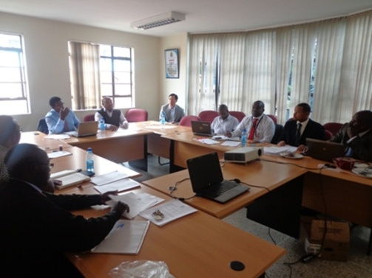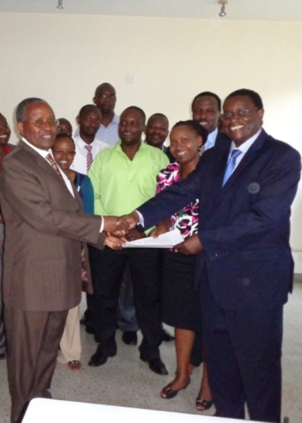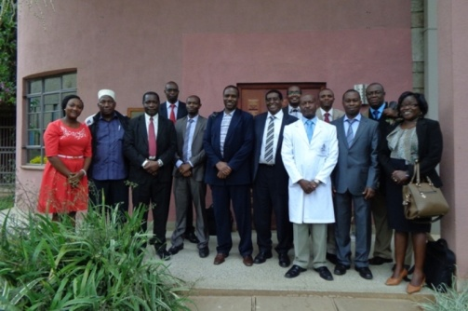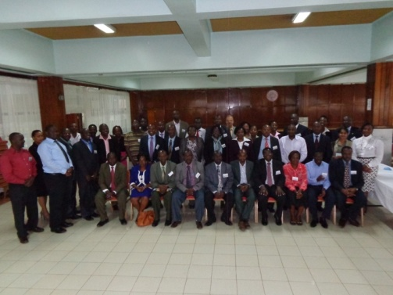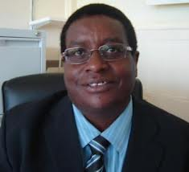[](http://www.uonbi.ac.ke/projects/unitidfp/)[](https://twitter.com/UoNFellowship)[](https://www.facebook.com/uonhivfellowship)[](http://www.linkedin.com/pub/uhiv-fellowship-capacity-building/99/455/b40)[](ttps://www.youtube.com/watch?v=cmK6WRZ0IvQ)

**Fellowship June 2014 Issue Follow us on:**

**Focus**

**E-Newsletter**

**(E-Zyne)**

**Online Edition**

The Summative Inception Forum was held on 10th Feb, 2014 at the UNITID Boardroom.

The purpose of the evaluation was to perform an overall review of the fellowship program in terms of its inputs, processes, outputs, impact and efficiency.

[Read More...](http://www.uonbi.ac.ke/projects/unitidfp/node/144)

The First Fellowship Consortium Meeting for the second phase of UHIV Fellowship program was held on 10th April, 2014. It was officiated by Prof. Isaac Kibwage, Principal College of Health Sciences.

 Meant to bring together the three partners: University of Nairobi Fellowship Team, University of Washington and Management Sciences for Health (MSH), the meeting focused on: [Read more...](http://www.uonbi.ac.ke/projects/unitidfp/node/147)

**First Fellowship Consortium Meeting**

*Prof. Isaac Kibwage, Principal CHS receives the official Notification Letter of The Second UoN HIV Capacity Building Fellowship (UHIV Fellowship) Grant from Prof. Kiarie (PI) and Josephine Mbiyu-Kinyua, MSH*

**Prof. James Kiarie**

**Principal Investigator (PI)**

The new phase of the fellowship focuses on developing and implementing a sustained national training. [Read more...](http://unitidfp.uonbi.ac.ke/node/143)

delivery on targets. ‘Our targets are our

commitments,’ He insisted.

Afterwards, Prof. James Kiarie (PI) gave a presentation on the new grant, agenda and scope of work for consortium. He clearly stated that emphasis of the fellowship was on competence, knowledge and skills and not necessarily certificates. [Read more](http://www.uonbi.ac.ke/projects/unitidfp/node/156)

The meeting was held on 2nd May, 2014 at the UNITID Board Room.

Prof. Isaac Kibwage, Principal College of Health Sciences, UoN officially opened the meeting by giving a welcoming address to members. He also emphasized on members

*UHIV Fellowship and Collaborating*

*Universities’ Team*

The UHIV Fellowship Stakeholders’ Meeting took place on 4th June, 2014 at the UoN Central Catering Conference Centre (CCU).

The main agenda was to bring together the Participating Local Partners

**The UHIV Fellowship and Collaborating Universities Meeting**

(PLPs); Collaborating Universities and the UHIV Fellowship consortium to discuss and deliberate on the gaps and needs to be addressed and the way forward in the implementation of the UoN HIV Capacity Building Fellowship. and the way forward in the implementation of the UoN HIV Capacity Building Fellowship.

The meeting agenda was based on the consideration of PLPs as the main focus in implementation of the program, and therefore, know better the gaps and needs to be addressed on the ground. [Read more….](http://www.uonbi.ac.ke/projects/unitidfp/node/158)

*The stakeholders’ Team at UoN CCU*

**UHIV Fellowship Stakeholders’ Forum**

**Program Director’s Message**

**Goal**

Developing and implementing a sustained national training program that builds the

capacity of Kenyan healthcare workers and local organizations through an academic

model of training to support the transition of HIV programs to local organizations

in alignment with the Kenya National AIDS Strategic Plan and the President's

Emergency Plan for AIDS Relief (PEPFAR)

**UoN HIV Capacity Building Fellowship**

*The Summative Evaluation Forum*

For more information and enquiries:

020 8080391